Introduction

There are some – including class action attorneys motivated by self-interests –
who are raising questions about the benefit of local MLS broker marketplaces* and REALTORS®. Each of us recognizes local real estate – buoyed by REALTORS® – is pro-consumer and pro-competitive. It’s important that we continue to find ways to communicate and amplify these realities to clients, consumers, media and other interested parties.

To that end, there are three communications toolkits to help explain the benefits of local broker marketplaces and REALTORS®:
- Fostering Competition: Primarily business and economics storytelling
- Consumer Access & Opportunity (this toolkit): Primarily business and consumer storytelling
- REALTORS® as Champions: Primarily consumer storytelling

These toolkits contain a variety of communications materials that can be used as is or customized for local markets. You also can cut and paste relevant portions to share with members, as appropriate.

If you have any questions about this or other toolkits, please contact Mantill Williams (MWilliams@nar.realtor) in NAR communications or Lesley Muchow (LMuchow@nar.realtor) in NAR legal.

Additional references and sites you can share, when pertinent, include competition.realtor (or the landing page Prohomebuyersandsellers.com to send someone directly to the “Consumer Access & Opportunity” section) or RealEstateCommissionFacts.com, if there’s a need to refer someone to content solely focused on how compensation works.

* Rather than refer only to Multiple Listing Services, we recommend a more explanatory term that better captures what MLSs are and how they operate: Independent, local broker marketplaces. It’s important that people understand there’s not a single broker marketplace; that each one is local or regional; and that each one has its own oversight organization. It can be appropriate to use different combinations of these terms depending on the context and on first or second reference, but “local broker marketplaces” is generally the term that best and most succinctly describes what they are. Note: More dated materials (e.g., older op eds) might not use the current, preferred terminology, but they may otherwise be a good resource for reference about pro-consumer, pro-competitive local broker marketplaces.
Consumer Access & Opportunity Table of Contents
[control/click to go direct to section]
About: Broker Marketplaces Enable Consumer Access & Opportunity 3
Key Facts 5
Consumer Access & Opportunity Q&A 7
Infographics/Fact Sheets 10
Key Articles 13
Key Quotes 16
Sample Social Media Posts 18
Sample 30-Second Radio Ad Scripts 21
Display Ad Guidance & Sample 23
Print Ad Guidance & Sample 24
Customizable Owned Content 25

About: How Local Broker Marketplaces Enable Consumer Access & Opportunity

Below are some key points (along with key facts that follow) to draw on for use in various communications about how local broker marketplaces provide the best value for consumers and provide them the greatest and most transparent, equitable and efficient access to homeownership. These points are reflected in the communications materials throughout this toolkit, but they could also be used in talking points or to create additional content. Note: Use of “compensation” is preferred to “commission” when interchangeable to allow for terminology that is more explanatory.
- Local MLS broker marketplaces ensure equity, transparency, efficiency and market-driven pricing options for home buyers and sellers.
- Local broker marketplaces are essentially databases of all the homes for sale in a given market, maintained in most cases by local REALTOR® associations.
  - Local REALTOR® associations make most of this information publicly available for free.
  - Each database often is the primary source of information for home search sites.
- When a seller lists a property on one of these local broker marketplaces with a listing broker, they get access to the largest pool of possible buyers that have been brought to the marketplace by buyer brokers.
  - Sellers also save time and money by working with an established group of buyer brokers.
- Buyers, in turn, can work with any buyer broker to see ALL homes for sale in one place without hidden or extra costs.
  - Guidelines require brokers to post marketed properties for sale in their local broker marketplaces so there is equitable access to homes for sale for all buyers.
- Typically, the seller’s broker pays the buyer broker’s compensation for finding a buyer in a local broker marketplace.
  - This practice gives all home buyers – particularly first-time and low/middle-income buyers – a better shot at affording a home and professional representation because those costs cannot be rolled into a mortgage.

- The free market organically establishes compensation costs within local real estate markets based on competition, service, consumer preference and what the market can bear, among other things.
  - At the outset, the seller and that person’s listing broker agree on the amount the listing broker will receive for the services provided to the seller.
  - The listing broker and seller also agree on an amount that the listing broker will pay a broker who successfully closes the sale with a ready, willing and able buyer.
  - Compensation is negotiable and can be negotiated at the outset or as agreed to by the parties at any time before the transaction closes.
  - Commissions fluctuate over time, including having decreased steadily in recent years. Average commission in the U.S. fell to new a new low of 4.94%, down from 5.4% in 2012. [Source]
- The U.S. model of local broker marketplaces has long been – and still is – viewed around the world as the best value for consumers.

Note: Facts about pro-consumer, pro-competitive compensation practices are best used in response to moments when you’re getting questions about that topic.

Key Facts

Consumer Economic Impact
- How local broker marketplaces work has been a driving force behind a thriving American real estate market. From 2010 to 2020, this approach to compensation has:
  - Enabled 87% of home buyers to purchase their home through a real estate broker [Source]
  - Contributed to an $8.2 trillion increase in total housing wealth [Source]
  - Helped 6.3 million more new buyers become homeowners [Source]
- The 90% of sellers who use a broker sell homes for 30% more, on average, than homes sold off a local broker marketplace. [Source] As an example, that means someone working with an agent could get $390,000 for their home, compared to just $300,000 if they tried to do it on their own.

Equitable Housing Opportunities
- Almost 9 out of every 10 home buyers use a mortgage to finance the purchase of their primary residence. Many of these buyers face significant hurdles in acquiring the upfront cash to cover down payment and closing costs. [Source]
- The typical American household has an average of $5,300 in the bank [Source], which is less than 33% of the median down payment on a starter home, which is $16,100 or 7% for first-time home buyers. [Source]
- If buyers had to pay commissions up front and out of pocket, they would be able to spend $33,450 – or 12% – less on a home. [Source]
- If buyers had to come up with the cash to compensate their agents up front and out of pocket on the sale of a $250,000 home, the seller would have to drop the asking price by 29% to close the deal with the potential buyer if that buyer were unable or unwilling to come up with the additional cash. Even if buy-side fees go down to as low as 1.5%, the seller would have to reduce the net asking price by 16% to enable the buyer to purchase the home without coming up with additional cash. [Source]
- Changing the current compensation model would pose the greatest harm to first-time, low-income, middle-income and minority buyers. Overall, U.S. homeownership rates, particularly among non-white buyers, would decline. Assets required to purchase a $250,000 home would increase from roughly $16,250 to $23,015. [Source]
- Most lenders don’t allow real estate broker compensation to be financed. As a result, for every 1% of broker commission fees that first-time buyers might have to pay, the price of a home grows by another $2,300. [Source]

U.S. vs. Abroad
- The home buying process abroad is like buying a car in the United States, where visiting multiple dealers is time consuming and impersonal, plus, on top of that, it would be like not knowing what’s for sale or where the cars are being sold.
- The U.S. approach is the most consumer-centric model. By consolidating fees and the overall process, our nation’s model simplifies the experience, provides greater certainty of success to both buyers and sellers, and provides guidelines that ensure the accuracy of housing inventory made available to real estate professionals and consumers, all at comparable or lower total costs than those in other countries.
- Buyers in other countries typically wade through a complex and fragmented market working with multiple brokerages, and there is no exclusivity, so sales often fall through. It’s common for brokers to charge fees and taxes in other countries that add up to the equivalent or greater of the costs associated with buying and selling property in the U.S. Still, brokers only provide a fraction of the services consumers receive here.
- For example, in Ireland, an auctioneer will charge a 1.5% fee to the seller and a lawyer requires a 1% fee to handle the transaction. The buyer must pay a 1%-3% transfer tax and then an additional 1% fee to a lawyer to purchase. Sellers also have to pay for brokerage signage, newspaper advertising, online ads, and brochures for potential buyers. As simultaneous closings are not practiced there, buyers routinely have to rent for 4-6 months between sale and purchase, adding thousands of more dollars to costs. [Source]

A World Without Local Broker Marketplaces
Access to inventory and widespread advertising as well as the practice of the listing broker paying the buyer brokers’ compensation incentivizes participation in local real estate marketplaces. Without that, the market would fragment and:
- There would be no centralized source of available homes for consumers or brokers.
- Buyers would spend more time and money visiting multiple brokers to see available properties.
- Home status information would be outdated.
- There would be fewer homes for buyers to choose from on real estate sites.
- Property information would become unverified, inaccurate and unreliable.
- Sellers would likely have to pay to list and advertise their properties on websites.
- Sellers would have to work with multiple brokers to access a meaningful pool of buyers.
- Buyers unable to afford brokerages would have fewer options.
- There would be inconsistent broker information in listings.
- Markets would be controlled by the largest brokers.

Consumer Access & Opportunity Q&A

Below are questions and answers we recommend using with consumers or other parties who have questions about how real estate professionals are paid.

How does the listing broker making offers of compensation to the buyer broker benefit consumers?
Listing brokers making offers of compensation to buyer brokers gives all home buyers, especially those who are first-time, low/middle income and racially underrepresented, a better shot at affording a home and professional representation. At the same time, studies have shown that without this practice, sellers would have to lower their asking prices. Because commissions cannot be financed as part of a mortgage, forcing buyers to pay their brokers out of pocket at closing would result in added financial burden to homeownership and reduce the pool of buyers competing for a seller’s home.

Could commissions be excluded from the selling/buying process and added to the mortgage instead?
Unlike mortgage broker fees, closing costs and appraisals, real estate sales commissions are not directly linked to the mortgage loan production and therefore cannot be financed. By definition, a mortgage is a lien against a property, which means the property itself serves as the asset that the lender can take back to recoup value if the borrower defaults. Commissions, on the other hand, are based on a service provided. There is no way for the lender to recover the value of the service in the event of a default on the mortgage. Further, lenders rely on investors to purchase mortgages to help fund these loans. Since mortgages do not include personal services, lenders and investors may be less willing to lend and invest if this were to change. Mortgages could become more costly, too.

Is compensation negotiable?
Compensation is negotiable and can be negotiated at the outset or as agreed to by the parties at any time before the transaction closes. Sellers negotiate with their broker what fee they are willing to pay for their broker’s services and what fee they are willing to pay a buyer broker for finding someone who wants to buy their home.

Is there a “set commission” real estate brokers charge consumers?
No. The market decides commission rates, and compensation is negotiable and can be negotiated at the outset or as agreed to by the parties at any time before the transaction closes. Consumers have the choice of who they want to pay and how they want to pay them. Because of the pro-consumer local MLS broker marketplace model, and options like a success fee, there is unprecedented competition among real estate brokers, especially when it comes to the service and commission options available to consumers.

Are there options for how/what broker compensation is paid?
Buyers have many different choices about which broker they want to work with: everything from the compensation model to a real estate agent’s particular expertise to the agents’ customer service approach. In the full-service approach, compensation is negotiable and can be negotiated at the outset or as agreed to by the parties at any time before the transaction closes. The reduced service/discounted fee model allows for flexible offerings and pricing. The flat fee approach allows buyers to negotiate a set price per service.

Why should real estate professionals make the money they do in commissions when so much information is available online?
Real estate brokers provide essential guidance as consumers navigate the legal, financial and community aspects of a purchase, including everything from determining property value to negotiating its price. They also make possible local broker marketplaces, which online housing portals tap into, because of all the information they input into those databases. In 2021, REALTORS®’ annual median gross income was $54,000 and 65% of REALTOR® are women.

Why are local MLS broker marketplaces needed when you can find listings for homes in so many places online?
The ability to find listings for homes online is made possible by virtue of local MLS broker marketplaces. Online home listing sites receive much of their inventory from these local broker marketplaces. That data exists because of real estate professionals and others’ commitment to cultivating comprehensive housing data reinforced by guidelines that ensure accuracy and transparency so consumers can confidently rely on the information.

How does the U.S. model compare to other, international broker marketplaces?
U.S. local broker marketplaces have long been — and are still — viewed as the best option for consumers around the world. By consolidating fees and the overall process, our nation’s model increases efficiency, simplifies the experience, provides greater certainty to buyers and sellers, and ensures the accuracy of housing inventory listings. This also often comes at comparable or lower total costs than those in other countries.

Infographics/Fact Sheets

Following are infographics you can copy and paste or save as a jpg to share as a handout or online as the situation warrants. You can also download a PDF version on competition.realtor or the direct “consumer access and opportunity” landing page prohomebuyersandsellers.com.

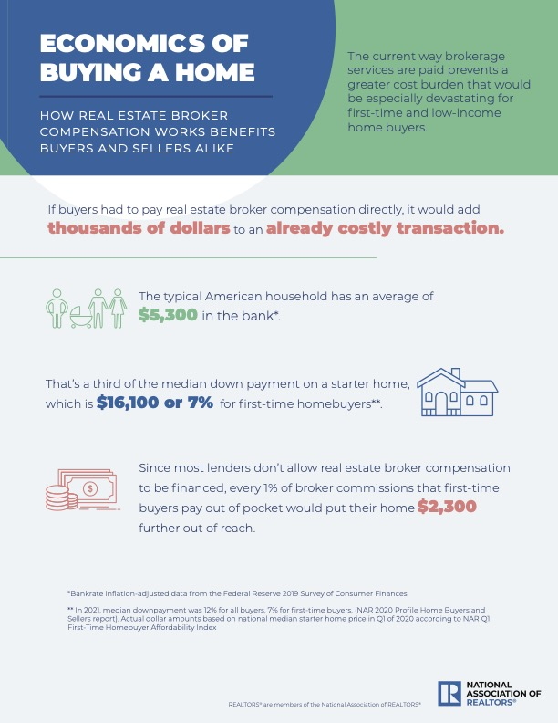
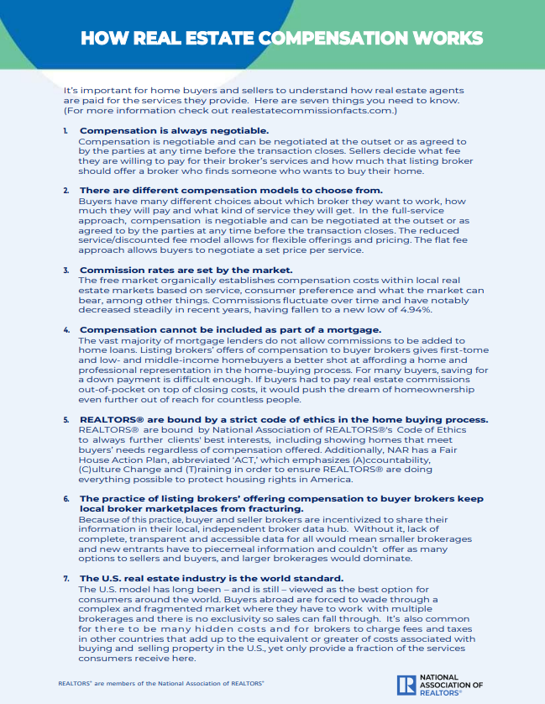
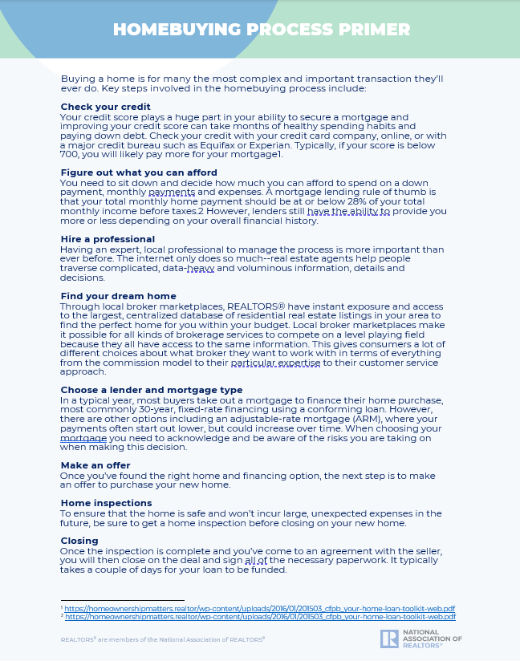

Key Articles

Following are articles (including excerpts here) that can serve as handouts, be excerpted from or provide inspiration for new content related to consumer access and opportunity. For additional articles of note, please check out the “consumer access & opportunity” section within “in the news” at competition.realtor.

STUDY: PROPOSED CHANGE TO COMISSION STRUCTURE THREATENS EQUITABLE ACCESS TO HOUSING
By HomeServices of America (HSOA)
Link

A new study has found that requiring prospective home buyers to pay real estate agents directly out of pocket would significantly suppress home buying opportunities for large segments of the population. “Be Careful What You Ask For: The Economic Impact of Changing the Structure of Real Estate Agent Fees,” illustrates how the changes would most significantly affect Black, Hispanic/Latino, first-time, and low- and middle-income buyers. The independent study was requisitioned by HomeServices of America as part of the company’s ongoing efforts to support equity in home buying.

OPINION: CHANGING REAL ESTATE COMPENSATION HARMS FAIR HOUSING
By Leslie Rouda Smith
Link

Critics argue that prospective home buyers should pay real estate agents directly out of pocket — as opposed to the more common practice of the listing broker paying the buyer broker’s compensation. What those critics fail to account for are negative effects this would have on fair housing in America.

This push toward “decoupling commissions” is a movement built on assumptions that have been dispelled — once again — by a recent, nationwide study that demonstrates the harmful effects this proposed change would have on the residential real estate market, particularly first-time home buyers and those from minority groups. “Be Careful What You Ask For: The Economic Impact of Changing the Structure of Real Estate Agent Fees,” was conducted by two former Freddie Mac executives and a former senior advisor at the Department of Housing and Urban Development.

STUDY: Bright’s 2022 on MLS Study
By Bright MLS
Link

Between 2019 and 2022, 83.4% of all home sales transactions took place on-MLS and sold for an average of 13.0% more than comparable homes sold off-MLS, amounting to an additional $45,741 to the seller for the typical home sold on the MLS over that period.

In 2021, on-MLS homes sold for an average of 14.8% more than off-MLS properties, a $55,779 premium.

As the market cools, the advantage of the open marketplace continues to increase with on-MLS properties selling for 19.7% more, on average, than off-MLS properties during the first quarter of 2022.

OPINION: WHY THE US MLS MODEL IS THE ENVY OF OTHER COUNTRIES
By Colin Mullane
Link

I have been following the discussion around the competitiveness, costs and consumer benefits of U.S. Multiple Listing Services (MLS) by those trying to disparage the system. As an Irish immigrant to the United States in 1996 who became a real estate broker in 2000, I can tell you this: The U.S. model has long been — and is still — viewed as the best by consumers around the world.

You don’t have to look very far for examples that illustrate why.

OP-ED: MLSs ADVANCE SMALL BUSINESS, EQUITY IN HOMEOWNERSHIP
By Charlie Oppler
Link

A critical foundation of American homeownership is the Multiple Listing Service (MLS). These independent, local broker marketplaces create highly competitive markets that are friendly to small business while ensuring equitable home ownership opportunities, superior customer service and greater options for buyers and sellers.

Simply put, local broker marketplaces provide sellers access to the largest possible pool of potential buyers while creating the greatest number of housing options for buyers in one, centralized location.

OP-ED: REAL ESTATE AGENT COMMISSION STRUCTURE BENEFITS EVERYDAY AMERICANS
By Charlie Oppler
Link

Those attempting to attack the real estate agent commission structure are cloaking their true intentions in misleading claims of consumerism. These class action attorneys and those illegitimately trying to position themselves in the real estate market are looking for a pay-out if they can confuse enough people with misinformation and glaring omissions. The reality is that the commission structure gives everyday Americans and small businesses critical advantages they otherwise wouldn’t get.

OP-ED: 6 REASONS NAR'S COMMISSION RULES WORK
By Anthony Lamacchia
Link

…I generally agree with Hanna that change is good, as he noted. It’s critical for the National Association of REALTORS® (NAR) to consider and reconsider how it supports transparency, competition and consumer choice in the real estate industry.

That’s precisely why NAR regularly reviews guidelines for local MLS broker [marketplaces]. A recent example of that is in September, NAR’s MLS Technology and Emerging Issues Advisory Board passed a series of motions that are designed to make sure multiple listing services best meet the needs of consumers, agents and brokers alike.

The changes would ensure local MLS market participants do not represent their services as free, do not restrict listings based on compensation being offered to a cooperating broker and disclose the listing agent offer of compensation to buyer’s agents. These motions also ensure participants are not filtering listings in any way by brokerage or agent.

Key Quotes

Below are quotes that serve as examples of how people are positively characterizing the pro-consumer benefits of local broker marketplaces and working with REALTORS®. You could use these quotes in content, speeches, online, etc., and for inspiration to develop statements from your leadership/executive teams.

“Changing the current compensation structure could affect potential buyers’ ability to qualify for a mortgage and purchase a home. Requiring buyers to pay their agent’s fee directly would result in reduced homeownership opportunities for cash-constrained families and lower net proceeds for many sellers. These outcomes would create negative ripple effects across the entire housing market.”
– Ann Schnare, Former VP at Freddie Mac, July 2022

"The commission trends seem to indicate that consumers have room to negotiate with their REALTORS®, a market reality that only intensified during the seller’s market of 2020."
– Jeff Ostrowski, senior mortgage reporter at Bankrate, March 2021

“…we find that changing the current compensation structure would suppress homebuying opportunities for large segments of the potential market, and that minorities, lower income households, and first-time home buyers who rely more heavily on agent services would suffer the most.”
– Ann Schnare, Former VP at Freddie Mac, Amy Crews Cutts, Chief Economist at National Association of Credit Management and BrightQuery, Vanessa Gail Perry, Fellow at Urban Institute Housing Finance Policy Center and George Washington University Professor, July 2022

"Large numbers of real estate agents vying for a small number of deals also encourages REALTORS® to compete by cutting their fees. It’s supply and demand...”
– Mike DelPrete, real estate scholar at University of Colorado Boulder, March 2021

“The cooperative MLS system exposes home listings to the largest number of potential buyers with an offer of compensation to any successful buyers’ agent. The U.S. MLS has spawned deeper collaboration among competitors where reliable, in-depth information is shared among participants, all to the benefit of the end consumers who get a fuller, more accurate look at the current housing market.”
– Colin Mullane, Principal Broker, owner of Full Circle Real Estate, July 2021

“Almost 9 out of every 10 home buyers use a mortgage to finance the purchase of their primary residence, and many of these buyers face significant hurdles in acquiring the upfront cash to cover down payment and closing costs. These cash constraints are more prevalent among first-time home buyers and racial minority groups. That is a factor that must be considered in any conversation about changing how buyers’ agents are typically compensated.”
– Dana Strandmo, Chief Administrative Officer at HomeServices of America, July 2022

"Calling the homebuying process ‘complicated’ is an understatement, and agents do much more than just ’find you a house.’ They help with price negotiations, make sure you are in compliance to local and state property taxes, and help walk you through mountains of paperwork."
– Al Dellibovi, former United States Deputy Secretary of Housing and Urban Development, October 2022

Sample Social Media Posts

The following social media posts can be used on your local association or personal/professional channels. These can be customized, supplemented with imagery or turned into infographics. All are within the 280-character count for Twitter but can be lengthened and customized for other channels.

Sample 1:
Buying a home is complex, here are key steps of the process:
1. Credit check
2. Determine budget
3. Hire a professional
4. Find dream home
5. Choose lender & mortgage type
6. Make an offer
8. Home inspection
9. Close & move in
(Learn more: bit.ly/3DQvbYL)

Sample 2:
Local broker marketplaces give first-time, low-income & other buyers better access to the American dream of homeownership while exposing a seller’s property to the greatest number of buyers. Learn more: bit.ly/3DQvbYL

Sample 3:
Local broker marketplaces provide sellers access to the largest pool of potential buyers while creating the greatest number of housing options for buyers in one centralized location. Learn more: bit.ly/3DQvbYL

Sample4:
Local MLS broker marketplaces are the driving force that make homeownership possible more than 5 million times annually. Learn more: bit.ly/3DQvbYL

Sample 5:
Local broker marketplaces are designed to give consumers the best, most efficient and transparent experience in buying or selling a home. Learn more: bit.ly/3DQvbYL

Sample 6: Real estate agent compensation is negotiable and can be negotiated at the outset or as agreed to by the parties at any time before the transaction closes. Learn more: bit.ly/3DQvbYL

Sample 7: The free market organically establishes compensation costs within local real estate markets based on competition, service, consumer preference and what the market can bear. Learn more: bit.ly/3DQvbYL

Sample 8: NAR’s Fair House Action Plan (ACT) emphasizes (A)ccountability, (C)ulture Change and (T)raining to ensure America’s 1.5 million REALTORS® are doing everything possible to protect housing rights in America. Learn more: bit.ly/3DQvbYL

Sample 9: Listing and buyer brokers contributing to local broker marketplaces sets the U.S. real estate industry apart from the rest of the world. Learn more: bit.ly/3DQvbYL

Sample 10: Local broker marketplaces act as an information-sharing platform among real estate agents. Consumers benefit because buyers see all homes for sale and sellers get the largest possible pool of buyers. Learn more: bit.ly/3DQvbYL

Sample 11: A home is the single largest, most complex purchase most people make in a lifetime. Working with a real estate agent gives buyers access to all the homes available in a market, thanks to local broker marketplaces. Learn more: bit.ly/3DQvbYL

Sample 12: Internet research about a home purchase reached an all-time high in 2020. Real estate agents help distill an overwhelming amount of online information for consumers. That’s why 9 in 10 ppl still chose to work with a real estate agent to buy a home. Learn more: bit.ly/3DQvbYL

Sample 13: NAR's Housing Opportunity Program offers programs, grants, trainings and resources that help REALTORS® expand housing availability for both rental housing & homeownership opportunities in their communities. Learn more: bit.ly/3frdVQ5

Sample 14: The hundreds of independent, local broker marketplaces across the country are the critical foundation of American homeownership and consumer access to fair housing. Learn more: bit.ly/3frdVQ5

Sample 15: U.S. local broker marketplaces are viewed as the best option for consumers around the world. By consolidating fees and the process, our nation’s model increases efficiency and benefits buyers and sellers. Learn more: bit.ly/3DQvbYL

Sample 16: U.S. local broker marketplaces are the envy of other countries because they spawn deeper collaboration where reliable, in-depth information is shared among participants, all to the benefit of the end consumers. Learn more: bit.ly/3DQvbYL

Compensation-related posts (Use these more selectively, such as if real estate commissions become a hot topic in a local market due to a third party raising questions about how compensation works)

Sample 17: Listing brokers making offers of compensation to buyer brokers gives first-time, low/middle-income and all home buyers a better shot at affording a home and professional representation. Learn more: bit.ly/3DQvbYL

Sample 18: If buyers had to pay real estate broker compensation directly, it would add thousands of dollars to an already costly transaction. Learn more: bit.ly/3DQvbYL

Sample 19: Unlike mortgage broker fees, closing costs and appraisals, real estate agent compensation cannot be financed. That’s why it’s important for listing brokers to make offers of compensation to buyer brokers. Learn more: bit.ly/3DQvbYL

Sample 20: REALTORS® are bound by NAR's Code of Ethics to always further clients' best interests, including showing homes that meet buyers’ needs regardless of compensation offered. Learn more: bit.ly/3DQvbYL

Sample 21: A recent study found that requiring prospective home buyers to pay real estate agents directly out of pocket would significantly suppress home buying opportunities for large segments of the population. Learn more: bit.ly/3T8fOQ0

Sample 30-Second Radio Ad Scripts

The following sample scripts can be used for local radio ads. Customize as you see fit and be sure to read aloud to ensure they align with applicable timing requirements.

Sample 1: Local broker marketplaces create more options for buyers and sellers

So you’re ready to buy a home. You look online at different sites that feature homes for sale. You talk to a REALTOR® for ideas. Guess where the vast majority of that information about homes for sale comes from?

Local broker marketplaces.

Those are the online portals where seller agents put client’s homes for sale and buyer agents come with buyers. It’s the most complete, accurate information on homes for sale in any given area.

To learn more about how local broker marketplaces advance consumer access to real estate, check out competition-dot-realtor.

Sample 2: Local broker marketplaces ensure equity for buyers and sellers

Not many people know this, but local broker marketplaces are the cornerstone of American real estate markets.

They are independent, local centralized hubs of real estate listings. They give home sellers access to the largest pool of potential buyers. And they create the greatest number of housing options for buyers.

The benefit of all this? They make equity, transparency, efficiency and market-driven prices possible for home buyers and sellers.

To learn more about how local broker marketplaces promote equity and accessibility in the housing market, visit competition-dot-realtor.

Compensation-related ad (Use more selectively, such as if real estate commissions become a hot topic in a local market due to a third party raising questions about how commissions work)

Sample 3: U.S. model of broker compensation makes home buying economics work

It’s no secret that buying a home is the most expensive purchase most people make in their lifetimes. Local broker marketplaces give buyers the best shot at affording that home.

That’s because sellers’ agents pay the commission of buyers’ agents. So buyers don’t have to pay that compensation out of pocket.

This practice has worked so well for so long because of what it does for buyers AND sellers. Sellers’ homes are exposed to more buyers. And buyers can work with any broker to see ALL homes for sale.

To learn more about how the U.S. model of broker compensation benefits all Americans, check out real-estate-commission-facts-dot-com.

Display Ad Guidance & Sample

Below you will find general guidance on commonly used specs for digital display advertisements, as well as a digital ad mockup as inspiration for a local association-branded ad (e.g., artwork, color palette, fonts, brand guidelines, etc.). Ad sizing will depend on placement location, so follow specs provided by the platform in which you wish to advertise (e.g., Facebook, Twitter, etc.).

Media Type | Common Ad Sizes | Creative Specs | Copy Needed | Suggested Creative & Variation
Digital display | 320x50, 728x90, 300x250, 300x600, 160x600 | File Type:  .jpg, .jpeg, .gif and .png  File Type (if animated):  .gif and HTML 5  Max Size:  10MB | Copy will vary greatly based on size, animated or not, and location of the ad | No more than 2-3 copy variations per topic

Below is an example of a 320x50 display ad

Print Ad Guidance & Sample

Below you will find general guidance on commonly used specs for print advertisements, as well as a magazine ad mockup as inspiration for a local association-branded ad (e.g., artwork, color palette, fonts, brand guidelines, etc.). Ad sizing will depend on placement location, so follow specs provided by the outlet in which you wish to advertise.
Media Type | Common Ad Sizes | Creative Specs | Copy Needed | Suggested Creative & Variation
Print | ½ or full-page (will vary by outlet) | File Type:  .jpg, .jpeg, .pdf  Full color | Copy will vary greatly based on size and outlet requirements | Recommend running same variations as digital for alignment

Customizable Owned Content

The following sample content can be used in a variety of ways in the form of owned content. Some examples include pitching as an op-ed or column to a local paper or magazine (typical required length runs from 500 to 750 words), posting as a thought leadership piece on an AE’s LinkedIn page, or sharing on your local association blog or website. Note that for earned media pitches and press releases, we typically respect media style preferences and use “Realtor®” vs. “REALTOR®.”

Local Broker Marketplaces Make Our Home Fantasies and Realities Possible

So many Americans are unabashedly obsessed with scrolling through online home listings. Looking at houses during the pandemic became a hobby that many people incorporated into their daily routines. After all, what could be more fun than “fantasy scrolling” and picking out your dream house or apartment, regardless of cost or location.

Trust me, I get it. As a Realtor® in [city/town], I love spending all day looking at houses too! And it’s really not surprising we all like it so much considering 97% of all buyers use the internet in their home search before 88% of them start working with a real estate agent.

What most people don’t know is that your fantasy home search – whether purely for fun or because you’re seriously considering buying a home – is made possible by local broker marketplaces like [local association MLS].

Local broker marketplaces, while not as well-known as many of the real estate browsing websites, are what allow home data to reach consumers. These marketplaces are essentially databases of all the homes for sale in a given market, maintained in most cases by local REALTOR® associations. Each database often is the primary source of information for home search sites.
These marketplaces are a product of seller real estate agents putting their information in the virtual marketplace while buyer real estate agents come to the marketplace with buyers for those homes.

The result? The most efficient, accurate and trusted information on properties in a place like [county/state].

And consumers on both sides of the home sale benefit.

When a seller lists a property on one of these local broker marketplaces with a listing broker, they get access to the largest pool of possible buyers that have been brought to the marketplace by buyer brokers. Sellers also save time and money by working with an established group of buyer brokers.
For buyers, they can work with any buyer broker to see ALL homes for sale in one place without hidden or extra costs. The very existence of local broker marketplaces enables equitable access for consumers, including first-time home buyers and low- or middle-income home buyers and racially under-represented groups.
I’ve been a Realtor® for more than [XX] years. I’ve been able to help people like [client first name] who [insert one sentence story about how client was overwhelmed by information on the internet and how access to local broker marketplace through the broker made their dream possible.]

Another aspect of these local broker marketplaces is that the seller’s broker pays the buyer’s broker compensation, or commission. And it’s a good thing. Since the buyer broker compensation can’t be incorporated into a mortgage, if buyers had to pay their brokers directly at closing, many would be priced out of the market.

Take for example [client first name] who was able to [insert one sentence story about how the home buyer had just enough to afford a down payment and dream home because they didn’t have to pay commission out of pocket.]

Yes, there’s a little bit of magic happening in these local broker marketplaces not just for people looking at homes for fun but for people trying – sometimes for the first time in their family – to build generational wealth by owning a home. There are more than 550 independent, local broker marketplaces across the country making the exchange of information and equitable access to that information possible.

So the next time you sit down to look at your fantasy [Hollywood Hills] or [Manhattan high rise] or [Arizona getaway] home online, you’ll know there is so much more to what you’re seeing. Behind it all are independent local broker marketplaces powered by inputs from local real estate agents that benefit you and millions of people trying to realize the American dream of homeownership.

###

November 2022

