Introduction

There are some – including class action attorneys motivated by self-interests –
who are raising questions about the benefit of local MLS broker marketplaces* and REALTORS®. Each of us recognizes local real estate – buoyed by REALTORS® – is pro-consumer and pro-competitive. It’s important that we continue to find ways to communicate and amplify these realities to clients, consumers, media and other interested parties.

To that end, there are three communications toolkits to help explain the benefits of local broker marketplaces and REALTORS®:
- Fostering Competition (this toolkit): Primarily business and economics storytelling
- Consumer Access & Opportunity: Primarily business and consumer storytelling
- REALTORS® as Champions: Primarily consumer storytelling

These toolkits contain a variety of communications materials that can be used as is or customized for local markets. You also can cut and paste relevant portions to share with members, as appropriate.

If you have any questions about this or other toolkits, please contact Mantill Williams (MWilliams@nar.realtor) in NAR communications or Lesley Muchow (LMuchow@nar.realtor) in NAR legal.

Additional references and sites you can share, when pertinent, include competition.realtor (or the landing page competitioninrealrestate.com to send someone directly to the “Fostering Competition” section) or RealEstateCommissionFacts.com, if there’s a need to refer someone to content solely focused on how compensation works.

* Rather than refer only to Multiple Listing Services, we recommend a more explanatory term that better captures what MLSs are and how they operate: Independent, local broker marketplaces. It’s important that people understand there’s not a single broker marketplace; that each one is local or regional; and that each one has its own oversight organization. It can be appropriate to use different combinations of these terms depending on the context and on first or second reference, but “local broker marketplaces” is generally the term that best and most succinctly describes what they are. Note: More dated materials (e.g., older op eds) might not use the current, preferred terminology, but they may otherwise be a good resource for reference about pro-consumer, pro-competitive local broker marketplaces.
Fostering Competition Table of Contents

[control/click to go direct to section]
About: Local Broker Marketplaces Foster Competition 3
Key Facts 4
Fostering Competition Q&A 5
Infographic 7
Key Articles 8
Key Quotes 10
Sample Social Media Posts 12
Sample 30-Second Radio Ad Scripts 14
Display Ad Guidance & Sample 16
Print Ad Guidance & Sample 17
Customizable Owned Content 18

About: Local Broker Marketplaces Foster Competition

Below are some key points (along with key facts that follow) to draw on for use in various communications about how local broker marketplaces foster competition. These points are reflected within the communications materials within this toolkit as well but could also be used in talking points or used to create additional content.
- Multiple Listing Services (MLSs) are independent broker marketplaces that focus exclusively on residential real estate in local real estate markets.
- Independent, local broker marketplaces foster innovation and create highly competitive markets that provide a friendly environment for businesses of all types and sizes, including small businesses and new market entrants.
- Individual brokers input their information into one or more local broker marketplace databases around the country, creating a series of hubs of local real estate market information where all broker participants have access to the same data.
- Access to inventory and widespread advertising, as well as the practice of the listing broker paying the buyer brokers’ compensation, incentivizes participation in these local real estate marketplaces and creates the largest, most accessible and most accurate source of housing information available to consumers.
- Having housing information concentrated and accessible in one place in local markets levels the playing field among brokerages, allowing smaller brokerages to compete with larger ones, and provides for unprecedented competition among brokers, including those with different service and pricing models.
- Real estate agents, including REALTORS® – who are mostly small business owners – are able to flourish in these independent, local broker marketplaces that provide more equitable access and more complete options for their clients.

Key Facts

Economic Impact
- Real estate accounts for nearly 17% of the nation’s GDP. [Source]
- Every home sale generates roughly $113,200 in local economic activity, and every two home sales support one American job. [Source]
- 89% of sellers list their homes in a local MLS broker marketplace, which is the number one source for sellers to list their home. [Source]
About Local Broker Marketplaces
- Each local broker marketplace provides quick, complete exposure to the largest and most centralized database of residential real estate listings in that local market.
- Businesses who participate in local real estate marketplaces compete on compensation, offering many different service and fee options ranging from varied compensation models to flat fees.
- Online home listing and brokerage websites get much of their listing data from local MLS broker marketplaces.
- Participants in local MLS broker marketplaces are guided by the Clear Cooperation Policy, which requires a listing broker to submit their listing to the marketplace within one business day of marketing a property to the public. This ensures equitable access to listings for all potential home buyers.
About Commissions
- The U.S. is seeing unprecedented competition among real estate brokers, especially when it comes to service and commissions.
- According to Real Trends, the average commission in the U.S. has fallen to a new low of 4.94%, down from 5.4% in 2012. [Source]

About REALTORS®
- In the real estate industry, there are 406,569 establishments, 83.3% of which employ fewer than 500 workers of a total of 2.1 million employees. [Source]
- Of the 1.5 million REALTOR® entrepreneurs across the country, more than 1.3 million (87%) are small businesses. [Source] 65% of REALTORS® are women. [Source]
- REALTORS® account for more than 4% of all U.S. small businesses. There are 31.7 million small businesses in America, including those with no employees, [source] of which 1.3 million are REALTORS®. [Source]
- REALTORS®, 88% of whom are single offices, typically have two full-time real estate licensees. [Source]

Fostering Competition Q&A

Below are questions and answers we recommend using with consumers or other parties who have questions about independent, local broker marketplaces and how they work.

How do local broker marketplaces advance competition and equity for small businesses and consumers?
Local MLS broker marketplaces level the playing field, allowing small brokerages to compete with large ones by creating hubs of local real estate market information where all broker participants have access to the same reliable and trusted data. As a by-product, these data hubs spur entrepreneurship and innovation, allowing consumers to choose the type of broker with whom they want to work and what fee options they prefer. This includes many different service and fee options, from varied commission models to flat fees.

Why are local MLS broker marketplaces needed when you can find listings for homes in so many places online?
The ability to find listings for homes online is made possible by virtue of local MLS broker marketplaces. Online home listing sites receive much of their inventory from these local broker marketplaces. That data exists because of real estate professionals and others’ commitment to cultivating comprehensive housing data reinforced by guidelines that ensure accuracy and transparency so consumers can confidently rely on the information.

Is there a “set commission” real estate agents charge consumers?
No. The market decides commission rates, and compensation is negotiable and can be negotiated at the outset or as agreed to by the parties at any time before the transaction closes. Consumers have the choice of who they want to pay and how they want to pay them. Because of pro-consumer local MLS broker marketplaces and options like a success fee, there is unprecedented competition among real estate agents, especially when it comes to the service and compensation options available to consumers.

How do local broker marketplaces benefit an open market?
Independent, local broker marketplaces are enabled by having listing brokers bring their sellers and buyer brokers bring their buyers to create the most comprehensive, efficient and accurate local housing market. This creates highly competitive markets that are also friendly to small businesses and new market entrants because everyone has access to the same information. These marketplaces also ensure market-driven pricing and the greatest visibility and equity for buyers and sellers. Buyers get access to the largest database of available homes in any given market and sellers get maximized visibility and buyers for their home.

How does the U.S. model compare to other, international broker marketplaces?
U.S. local broker marketplaces have long been — and are still — viewed as the best option for consumers and fairness in business competition around the world. By consolidating fees and the overall process, our nation’s model increases efficiency, simplifies the experience, provides greater certainty of success to both buyers and sellers, and provides guidelines that ensure the accuracy of housing inventory. This ensures listings and housing opportunities are made equitably available and are uniformly accessible to real estate professionals and consumers across the country. And this is all done at comparable or lower total costs than those in other countries. At the same time, local broker marketplaces give small and new brokerages exposure to the same listings as large brokers, enabling them to fairly compete.

Infographic

Following is an infographic you can copy and paste or save as a .jpg to share as a handout or online as the situation warrants. You can also download a PDF version on competition.realtor or the “fostering competition” landing page at the site at competitioninrealrestate.com.
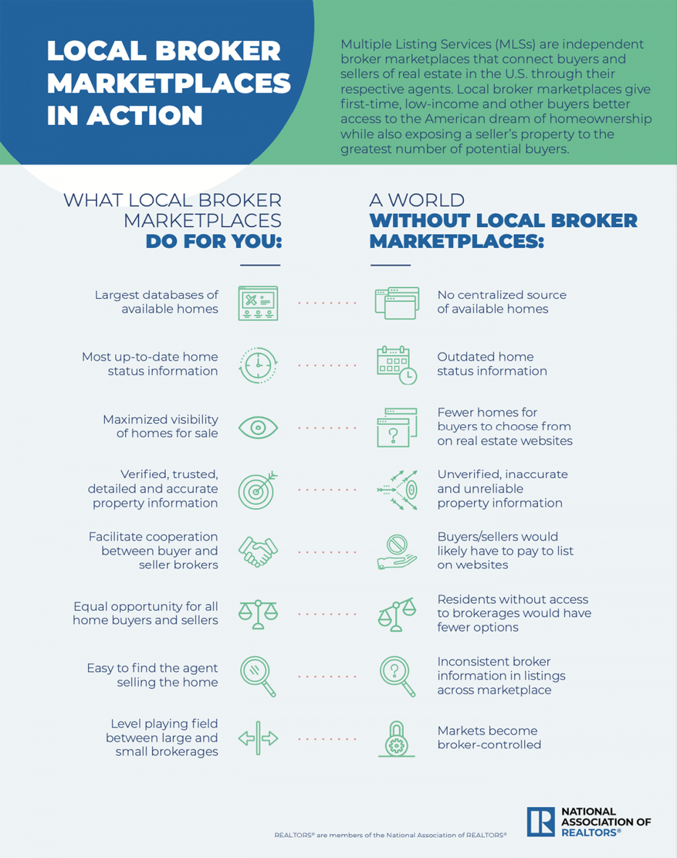

Key Articles

Following are articles (including excerpts here) that can serve as handouts, be excerpted from or provide inspiration for new content related to fostering competition. For additional articles of note, please check out the “local broker marketplaces foster competition” section within “in the news” at competition.realtor.

OP-ED: SMALL BUSINESSES, COOPERATION BOLSTER REAL ESTATE MARKET BY MAINTAINING AFFORDABILITY, EQUITY
By Ron Phipps
Link

As more than 31 million small businesses across the country were recognized during National Small Business Week, it’s a good time to look at how small, local operations drive so much of the economy and search for ways to continue to level the playing field for them and for consumers. When it comes to “buying local,” small businesses could not be more front and center than when it comes to purchasing a home. In fact, of the 1.5 million REALTORS® across the country, more than 1.3 million are small businesses like me who are focused on our local communities.

Of course, the local economic impact of housing is about more than just real estate agents. Preparing a home for the market often involves photographers, cleaners, landscapers, decorators and more, many of whom are small business owners themselves. Taken in total, small business has a significant impact on real estate – in fact, every home sale generates roughly $88,000 in local economic activity, and every two home sales supports one American job. Overall, real estate accounts for nearly 18% of the nation’s GDP.

OP-ED: MLSs ADVANCE SMALL BUSINESS, EQUITY IN HOMEOWNERSHIP
By Charlie Oppler
Link

A critical foundation of American homeownership is the Multiple Listing Service (MLS). These independent, local broker marketplaces create highly competitive markets that are friendly to small business while ensuring equitable home ownership opportunities, superior customer service, and greater options for buyers and sellers.

Simply put, local broker marketplaces provide sellers access to the largest possible pool of potential buyers while creating the greatest number of housing options for buyers in one, centralized location.

OP-ED: 6 REASONS NAR'S COMMISSION RULES WORK
By Anthony Lamachhia
Link

…I generally agree with Hanna that change is good, as he noted. It’s critical for the National Association of REALTORS® (NAR) to consider and reconsider how it supports transparency, competition, and consumer choice in the real estate industry.

That’s precisely why NAR regularly reviews guidelines for local MLS broker marketplaces. A recent example of that is in September, NAR’s MLS Technology and Emerging Issues Advisory Board passed a series of motions that are designed to make sure multiple listing services best meet the needs of consumers, agents, and brokers alike.

The changes would ensure local MLS market participants do not represent their services as free, do not restrict listings based on compensation being offered to a cooperating broker, and disclose the listing agent offer of compensation to buyer’s agents. These motions also ensure participants are not filtering listings in any way by brokerage or agent.

Key Quotes

Below are quotes that serve as examples of how people are positively characterizing competition in real estate. You could use these quotes in content, speeches, online, etc., and for inspiration to develop statements from your leadership/executive teams.

"I cannot think of any other industry that has more cooperation among competition for the good of the consumer than in real estate… Local broker MLS marketplaces level the playing field among brokerages, enabling small brokerages to compete with large ones, and newer REALTORS® to compete with experienced top REALTORS® and so on."
– Anthony Lamacchia, broker-owner of Lamacchia Realty, October 2021

"Real estate listings aren’t simply picked up from websites or public sources, they are created, licensed, vetted, verified, marketed, publicized and shared by independent contractors and small business real estate professionals like me and my team, and then posted on localized data hubs. These hubs allow even the smallest businesses to immediately compete with large ones.”
– Ron Phipps, Principal Broker at Phipps Realty Inc., September 2021

"A critical foundation of American homeownership is independent, local broker marketplaces that create highly competitive markets that are friendly to small business while ensuring equitable home ownership opportunities, superior customer service and greater options for buyers and sellers.”
– Charlie Oppler, 2022 Immediate Past President of National Association of REALTORS®, September 2021

"U.S. local MLS broker marketplaces create competitive, efficient markets that benefit home buyers and sellers as well as small business brokerages. These marketplaces enable brokers to share all their information in one place, providing the best and greatest number of options for buyers as efficiently and transparently as possible. In turn, sellers get access to the largest possible pool of buyers within a market. At the same time, local broker marketplaces give small and new brokerages exposure to the same listings as large brokers, enabling them to fairly compete.”
– Katie Johnson, General Counsel and Chief Member Experience Office, National Association of REALTORS®, September 2022

“In the end, competition has prevailed, at least for now. Greater transparency, easier home searches. No hidden cache of listings, more exposure for home sellers. No bias favoring large brokerages, competition on an equal footing.”
– Bob Mathew, principal broker with MXW Real Estate in the Washington, D.C. area, March 2021

“The real estate industry is unique in that it’s set up to be competitive because broker compensation is reliant on being successful. The market is telling us that the current compensation model is the most efficient way to be competitive.”
– Ken Johnson, Ph.D., Associate Dean at Florida Atlantic University & Editor of the Journal of Housing Research, November 2022

Sample Social Media Posts

The following social media posts can be used on your local association or personal/professional channels. These can be customized, supplemented with imagery or turned into infographics. All are within the 280-character count for Twitter but can be lengthened and customized for other channels.

Sample 1:
More than 80% of homes are sold in pro-consumer, pro-competitive, independent local broker marketplaces. Learn more: bit.ly/3NnTXCA

Sample 2:
Thanks to local MLS broker marketplaces, online home listing and brokerage websites are able to access most of the listing data they use. Learn more: bit.ly/3NnTXCA

Sample 3:
Local MLS broker marketplaces spur entrepreneurship and innovation, allowing consumers to choose the type of broker they want to work with and what fee options they prefer. Learn more: bit.ly/3NnTXCA

Sample 4:
Every home sale generates roughly $113,200 in economic activity in local markets, and every two home sales support one American job. Learn more: bit.ly/3NnTXCA

Sample 5:
REALTORS® are entrepreneurs — most often small business owners — who exemplify the spirit of this country. Thanks to local broker marketplaces, we’re seeing unprecedented new market entrants into real estate. Learn more: bit.ly/3NnTXCA

Sample 6:
For those trying to break into the real estate market, local MLS broker marketplaces level the playing field, allowing small brokerages to compete with large ones by creating hubs of local real estate market information. Learn more: bit.ly/3NnTXCA

Sample 7:
Local MLS broker marketplaces give small and new brokerages exposure to the same listings as large brokers, enabling them to fairly compete. Learn more: bit.ly/3NnTXCA

Sample 8:
Independent, local broker organizations create highly competitive markets that are friendly to small businesses. Learn more: bit.ly/3NnTXCA

Sample 9:
The U.S. real estate model has worked so well for so long because it provides the greatest economic benefits for buyers and sellers. Learn more: bit.ly/3NnTXCA

Sample 10:
Local MLS broker marketplaces create competitive, efficient markets that benefit home buyers and sellers as well as small business brokerages. Learn more: bit.ly/3NnTXCA

Sample 11:
Businesses who participate in local real estate marketplaces compete on commission, offering many different service and fee options, from varied commission models to flat fees. Learn more: bit.ly/3NnTXCA

Sample 12:
Local MLS broker marketplaces create fertile ground for small businesses to flourish. Learn more: bit.ly/3NnTXCA

Sample 13:
REALTORS® are mostly small business owners who work to ensure buyers and sellers have the greatest access, transparency and choice through independent, local broker marketplaces that level the playing field for all brokerages. Learn more: bit.ly/3NnTXCA

Sample 14:
Local MLS broker marketplaces in [CITY/STATE] provide quick, complete exposure to the largest centralized database of residential real estate listings in our market.
Learn more: bit.ly/3NnTXCA

Sample 15:
The U.S. is seeing unprecedented competition among real estate brokers, especially when it comes to service and commissions. According to Real Trends, the average commission in the U.S. has fallen to a new low of 4.94%, down from 5.4% in 2012. Learn more: bit.ly/3NnTXCA

Sample 30-Second Radio Ad Scripts

The following sample scripts can be used for local radio ads. Customize as you see fit, and be sure to read aloud to ensure they align with applicable timing requirements.

Sample 1: Local broker marketplaces spur business innovation that benefits consumers

Local MLS broker marketplaces spur entrepreneurship and business innovation.

Businesses who participate in local real estate marketplaces compete on commission. They offer many different service and fee options, from varied commission models to flat fees.

The benefit for consumers? You get to choose the best broker for you. That means choosing what fee options suit you best.

To learn more about how local broker marketplaces promote all kinds of business models that benefit consumers, check out competition-dot-realtor

Sample 2: Small business REALTORS® able to compete in local broker marketplaces

Of the 1.5 million REALTORS® across the country, more than 1.3 million are small businesses. And 65 percent are women-owned.

Thanks to local broker marketplaces, brokerages of all kinds and sizes can compete on a level playing field. That’s because these independent broker marketplaces give everyone access to the same reliable data.

To learn more about how local broker marketplaces create equal opportunity for businesses of all sizes, check out competition-dot-realtor

Sample 3: Local broker marketplaces are economic engines that work because everyone contributes

Real estate is a big driver of local economies. Every home sale generates more than $100,000 in economic activity. And every two home sales support one American job.

The magic behind residential real estate markets? Independent broker marketplaces.

Brokers put their seller or buyer details into one or more local marketplace databases. That gives fellow participants access to all the same information. And that gives their clients access, too.

To learn more about how local broker marketplaces work, check out competition-dot-realtor

Display Ad Guidance & Sample

Below you will find general guidance on commonly used specs for digital display advertisements, as well as a digital ad mockup as inspiration for a local association-branded ad (e.g., artwork, color palette, fonts, brand guidelines, etc.). Ad sizing will depend on placement location, so follow the specs provided by the platform in which you wish to advertise (e.g., Facebook, Twitter, etc.).

Media Type | Common Ad Sizes | Creative Specs | Copy Needed | Suggested Creative & Variation
Digital display | 320x50, 728x90, 300x250, 300x600, 160x600 | File Type:  .jpg, .jpeg, .gif and .png  File Type (if animated):  .gif and HTML 5  Max Size:  10MB | Copy will vary greatly based on size, animated or not, and location of the ad | No more than 2-3 copy variations per topic

Below is an example of a 320x50 display ad

Print Ad Guidance & Sample

Below you will find general guidance on commonly used specs for print advertisements, as well as a magazine ad mockup as inspiration for a local association-branded ad (e.g., artwork, color palette, fonts, brand guidelines, etc.). Ad sizing will depend on placement location, so follow the specs provided by the outlet in which you wish to advertise.
Media Type | Common Ad Sizes | Creative Specs | Copy Needed | Suggested Creative & Variation
Print | ½ or full-page (will vary by outlet) | File Type:  .jpg, .jpeg, .pdf  Full color | Copy will vary greatly based on size and outlet requirements | Recommend running same variations as digital for alignment

Customizable Owned Content

The following sample content can be used in a variety of ways in the form of owned content. Some examples include pitching as an op-ed or column to a local paper or magazine (typical required length runs from 500 to 750 words), posting as a thought leadership piece on an AE’s LinkedIn page, or sharing on your local association blog or website. Note that for earned media pitches and press releases, we typically respect media style preferences and use “Realtor®” vs. “REALTOR®.”

One thing’s for certain:
Local broker marketplaces
empower small businesses
to compete, thrive

In a world of economic uncertainty, there’s one thing you can count on: the American small business. In fact, small businesses create net new jobs nearly twice as fast as large businesses. That’s two-thirds of all new jobs in America in any given year. So, it only makes sense that we should protect and promote things that allow small businesses to flourish.

[NOTE: Option in first paragraph to work in/substitute a reference for a news hook to this recent survey that found 80% of small businesses are confident they can withstand an economic downturn.]

As [role and affiliation], I know all too well the importance and impact of small business. Nationally, 87% of Realtors® are small business people and make up more than 4% of the 31.7 million small businesses in the United States, where real estate accounts for 17% of our nation’s GDP. Here in [city/county/state], [#] of our members are small businesses out of [#] small businesses in the area.

And while most people can cite a small business Realtor® they know, most don’t understand how all these jobs are made possible. What’s more, it’s often difficult to comprehend how these small business owners are able to compete with much larger businesses.

Underpinning it all are independent, local broker marketplaces across the country.
Also known as multiple listing services (MLSs), these marketplaces create equal opportunity for businesses and real estate brokerages of all sizes. Individual real estate agents input their information into one or more local MLS broker marketplace database to create a series of hubs of local real estate market information where all broker participants have access to the same data.

Access to inventory and widespread advertising incentivizes participation in these local real estate marketplaces and levels the playing field among brokerages, which in turn, allows small brokerages to compete with large ones.

That creates a business-friendly environment for entities of all types and sizes, including new market entrants. And in the process, it provides for unprecedented competition among brokers, including those with different service and pricing models.

Take, for instance, Realtor® [name] of [city/neighborhood] who was able to [story in a sentence.]

Or [name] of [city/neighborhood] who [story in a sentence].

Or [name] of [city/neighborhood] who [story in a sentence].

Each of those small businesses were made possible for [first name] and [first name] and [first name] because of their access to data in the local broker marketplace.

The same can’t be said for small real estate brokers trying to break through in most other countries. Something like independent local broker marketplaces simply doesn’t exist.

With rare exception, a few major brokerages dominate in countries like Ireland because there isn’t a place where listing (seller) and buyer brokers share their information about homes for sale and provide ready and willing buyers. This forces smaller brokerages and new entrants to piecemeal information and limits the number of options they can offer sellers and buyers. As a result, larger brokerages dominate the market, limiting competition. In turn, choices are limited for consumers.

So, at a time when so much is uncertain, I’m grateful local broker marketplaces remain a safe haven for competition. A place where innovation and opportunity are possible. A place where small businesses know they can thrive. And a place that ultimately makes the American dream of homeownership possible for millions of people.

[name], [title], [organization]

###

November 2022

