Introduction

There are some – including class action attorneys motivated by self-interests –
who are raising questions about the benefit of local MLS broker marketplaces* and REALTORS®. Each of us recognizes local real estate – buoyed by REALTORS® – is pro-consumer and pro-competitive. It’s important that we continue to find ways to communicate and amplify these realities to clients, consumers, media and other interested parties.

To that end, there are three communications toolkits to help explain the benefits of local broker marketplaces and REALTORS®:
- Fostering Competition: Primarily business and economics storytelling
- Consumer Access & Opportunity: Primarily business and consumer storytelling
- REALTORS® as Champions (this toolkit): Primarily consumer storytelling

These toolkits contain a variety of communications materials that can be used as is or customized for local markets. You also can cut and paste relevant portions to share with members, as appropriate.

If you have any questions about this or other toolkits, please contact Mantill Williams (MWilliams@nar.realtor) in NAR communications or Lesley Muchow (LMuchow@nar.realtor) in NAR legal.

Additional references and sites you can share, when pertinent, include competition.realtor (or the landing page Homeownershipchampions.com to send someone directly to the “REALTORS® as Champions” section) or RealEstateCommissionFacts.com, if there is a need to refer someone to content solely focused on how compensation works.

* Rather than refer only to Multiple Listing Services, we recommend a more explanatory term that better captures what MLSs are and how they operate: Independent, local broker marketplaces. It’s important that people understand there’s not a single broker marketplace; that each one is local or regional; and that each one has its own oversight organization. It can be appropriate to use different combinations of these terms depending on the context and on first or second reference, but “local broker marketplaces” is generally the term that best and most succinctly describes what they are. Note: More dated materials (e.g., older op eds) might not use the current, preferred terminology, but they may otherwise be a good resource for reference about pro-consumer, pro-competitive local broker marketplaces.

REALTORS® As Champions Table of Contents
[control/click to go direct to section]
About: REALTOR® As Champions 3
Key Facts 4
Value of a REALTOR® Q&A 6
Infographics 8
Key articles 10
Key quotes 13
Sample Social Media Posts 15
Sample 30-Second Radio Ad Scripts 18
Display Ad Guidance & Sample 20
Print Ad Guidance & Sample 21
Customizable Owned Content 22

About: REALTOR®s as Champions

Below are some key points (along with key facts that follow) to draw on for use in various communications about how REALTORS®* are champions of consumers. These points are reflected throughout this toolkit’s communications materials, but they could also be used in talking points or to create additional content.
- REALTORS® are everyday working Americans who champion homeownership and property rights for the communities they serve.
- REALTORS® are entrepreneurs and most often small business owners who exemplify the spirit of this country.
- As engaged neighbors, REALTORS® are committed to building and enhancing the communities we serve and advocating for fair housing for all.
- Regardless of how you find a property, expert real estate agents help take the stress out of the home buying process and navigate what is for many the most complex and important transaction they’ll ever do.
- Real estate agents who are REALTORS® help consumers with:
  - Community knowledge – such as imparting information on local property taxes and providing objective resources on neighborhoods
  - Financial aspects – such as coordinating with lenders and researching mortgage rates
  - Legal matters – such as helping buyers manage required state and federal forms and closing documents
- Every REALTOR® is bound by a strict code of ethics based on professionalism, consumer protection and the golden rule.

* Note: A reminder that according to NAR brand guidelines, “REALTOR®” is meant to be used when there is a tieback to association membership. “Real estate agent” is the preferred usage when referring to the vocation more generally. You also can use the Mark properly by saying “real estate agents who are REALTORS®”.

Key Facts

The Business
- Of the 1.5 million REALTORS® across the country, more than 1.3 million (88%) are small businesses. [Source]
- 65% of REALTORS® are women. [Source]
- REALTORS® account for more than 4% of all U.S. small businesses. [Source] There are 31.7 million small businesses in America, including those with no employees [source], of which 1.3 million are REALTORS® [Source].
- REALTORS®, 78% of whom are single offices, typically have two full-time real estate licensees. [Source]
- The median gross income of REALTORS® was $54,000 in 2021. [Source]

Value to Consumers
- 88% of buyers purchased their home through a real estate agent or broker, an increase from 69% in 2001. [Source]
- 90% of home buyers would use their agent again or recommend their agent to others. [Source]
- 83% of first-time home buyers say their real estate agent helped them understand the home buying process. [Source]
- While 97% of home buyers do research about a home online, 9 in 10 people still choose to hire a real estate agent. [Source]
- 91% of home buyers see their real estate agents as a useful source of information. [Source]
- 97% of home buyers touted their REALTOR’S® honesty and integrity. [Source]
- More than 50% of buyers said agents helped them collect more valuable information from online listings than buyers could have uncovered on their own. [Source]

Philanthropy
- 79% of REALTORS® made charitable donations in 2021. The median annual value of REALTORS® associations’ donations to communities more than doubled in just three years, from $5,000 in 2018 to $12,000 in 2021. [Source]
- Two out of three REALTORS ® – 66% – volunteered monthly, spending an average of eight hours volunteering each month. [Source]
- 90% of broker-owners made donations in 2021. [Source]
- 77% of broker-owners volunteered their time on a monthly basis in 2021. [Source]
- 88% of AEs or MLS staff made personal donations in 2021. [Source]
- 90% of AE or MLS respondents' associations conducted a fundraiser for their community in 2021. [Source]

Fair Housing

As part of the National Association of REALTORS® and in local communities, REALTORS® engage in and advocate for things that advance fair housing, such as:
- The Housing Opportunity Program offers programs, grants and resources to help REALTORS® expand housing availability and ensure an adequate supply of rental housing and homeownership opportunities are available in their communities. [Source]
- Work with veterans’ groups, specifically the VA Home Loan Guaranty Program, to help veterans achieve the American dream of homeownership. [Source]
- Fair Housing Action Plan, (ACT) emphasizes (A)ccountability, (C)ulture Change and (T)raining to ensure REALTORS® are doing everything possible to protect housing rights in America. [Source] For example:
  - Fairhaven.realtor, an online simulation training where agents work against the clock to sell homes while confronting discrimination in the homebuying process.
  - Unconscious-bias training and education on how the actions of REALTORS® shape communities.
  - Work to ensure state licensing laws include effective fair-housing training requirements and hold real estate agents accountable to their fair housing obligation.
  - Spotlight real estate leaders who exemplify the best fair housing practices and workplace diversity.
  - Materials to help REALTORS® avoid fair housing pitfalls when they provide consumers with information on schools.
- Partner with the Mortgage Bankers Association, NAACP, National Urban League, National Fair Housing Alliance and the National Housing Conference, among others, as part of the 3 by 30 coalition, which is working to identify actionable and scalable steps that will make it possible to increase Black homeownership by 3 million net new homeowners by 2030. [Source]
- Increased funding for fair housing and affordable housing efforts to expand housing options, provide loan assistance and increase investments in distressed neighborhoods. [Source]

Professionalism

- REALTORS® complete ethics training of at least 2½ hours every three years.
- Members also are offered programs such as the C2EX (Commitment to Excellence) to assess their expertise in 10 (11 for brokers) elements of professionalism, from customer service to the proper use of technology.

Value of a REALTOR® Q&A

Below are questions and answers we recommend using with consumers or other parties who have questions about the value a REALTOR® (or real estate agent when referenced more broadly) brings to the home buying and selling process.

Why should a home buyer use a real estate agent?
A real estate agent who is a REALTOR® is an expert in helping a home buyer with one of the largest and most complex purchases most people will make in their lifetime. Real estate agents who are REALTORS® help people navigate legal (e.g., attorney reviews; required state and federal forms; closing documents), financial (e.g., lenders; mortgage rates and terms; appraisals and inspections) and community (e.g., property taxes; public property information; price trends; neighborhoods) aspects of the purchase. This expertise is even more critical for first-time, low-income and racially under-represented home buyers.

Why should a home seller use a real estate agent?
A home seller should use a real estate agent who is a REALTOR® because a REALTOR® has specific expertise they can bring to each transaction. When a home seller tries to go at it alone, also known as “For Sale by Owner” (FSBO), they tend to lose out on potential value for their homes. According to the 2022 Home Buyers and Sellers Report, FSBO homes sold for about 35% less than agent-assisted properties. FSBO homes sold at a median of $225,000 in 2021, significantly lower than the median of agent-assisted homes at $345,000. Even these FSBO sellers know the value of the buyer broker and typically offer some sort of compensation.

According to a 2022 Bright MLS study, between 2019 and 2022, 83.4% of all home sales transactions took place on a local broker marketplace and sold for an average of 13% more than comparable homes. This amounts to an additional $45,741 to the seller for the typical home sold on the local broker marketplace over that period.

How do real estate professionals advance the economy?
Homeownership benefits individuals and communities. Homeownership is the most common way the average family builds generational wealth – and, in turn, closes the gap between the rich and poor. Every home sale at the median generates roughly $113,000 of economic impact, accounting for nearly 17% of the nation’s GDP, and every home sale generates two American jobs. Those jobs include the 88% of REALTORS® who are small business owners.

Given so much is available online, why should I use a real estate agent?
Expert real estate agents who are REALTORS® save home buyers time and money and help take the stress out of the process. In fact, 90% of home buyers say they would engage their real estate agent again or recommend them to others. For home sellers, agents ensure your property is seen by the maximum number of buyers by utilizing their local broker marketplaces, the number one source for sellers to list their homes. In fact, studies consistently show that houses sell for more when using a real estate agent, rather than FSBO. Buyers, in turn, get access to the largest marketplace of homes for sale through a real estate agent and the expertise of a real estate agent to navigate through all the community, legal and financial aspects of your home purchase.

Why should real estate professionals make the money they do in commissions when so much information is available online?
Real estate agents who are REALTORS® provide essential guidance as consumers navigate the legal, financial and community aspects of a purchase, including everything from determining property value to negotiating prices. They also make possible local broker marketplaces — the source of most information for online housing portals — because of all the information they input into those databases. According to our member survey, a REALTOR’S® annual median gross income is about $54,000 and 88% are small businesses, a majority of which are women-owned.

Infographics

Following are infographics you can copy and paste or save as a jpg to share as a handout or online as the situation warrants it. You can also download a PDF version on competition.realtor or the direct “REALTORS® as champions” landing page homeownershipchampions.com.

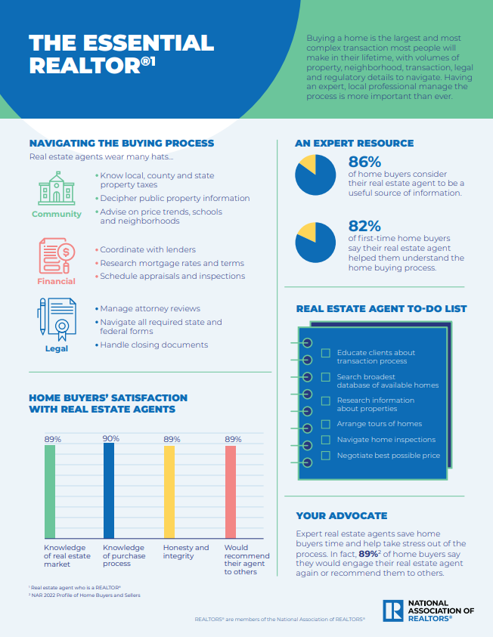

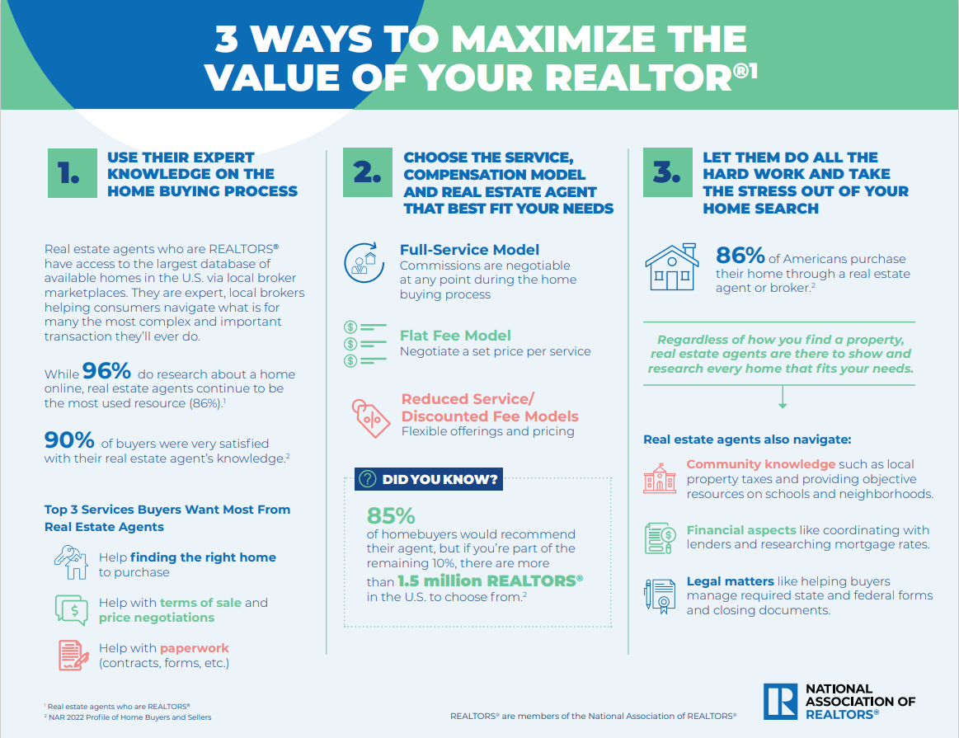

Key Articles

Following are articles (including excerpts here) that can serve as handouts, be excerpted from or provide inspiration for new content related to the value of a REALTOR®. For additional articles of note, please check out the “REALTORS® as Champions” section within “in the news” at competition.realtor.

OP-ED: DO I NEED A REALTOR TO BUY A HOUSE
By Craig Berry
Link

…Anyone who’s shopping for a home knows it’s a historically tough market.

Until recently, home buyers have enjoyed near-record-low interest rates. But today, they face a housing environment with rapidly increasing rates and scarce supply. Suppressed inventory levels in most parts of the country caused home prices to increase by nearly 20% between April 2021 and April 2022.

If you want to win a home in these conditions — and be sure you’re making a sound investment — a great Realtor can be your biggest asset.

Having a knowledgeable agent on your side, knowing exactly what to offer in a bidding war, and how to structure the offer, could be the difference in whether or not you win the home of your dreams.

GROWTH OF TECHNOLOGY MAKES IT EVEN MORE IMPORTANT TO USE A REALTOR
NAR
Link

In one sense, technology has made real estate more accessible for both buyers and sellers. And yet, while everyone can see detailed property records on their phones or computer within seconds, not everyone can be a negotiator, price setter or resource. Home buyers and sellers can have difficulty navigating the expanse of information available, leaving many unsure how best to use this data to their respective advantage.

“Technology will continue to improve and, in some cases, automate some aspects of the search and transaction,” NAR CEO Bob Goldberg said. “However, the widespread proliferation of real-estate technology, resources and information often leaves consumers feeling overloaded and overwhelmed.”

OP-ED REAL ESTATE STILL NEEDS THAT HUMAN TOUCH
By Bob Goldberg
Link

Much of life moved online during the pandemic. That became true for even the most tangible of goods—real estate.
Over the past 18 months, virtual walkthroughs and three-dimensional tours have replaced many in-person showings and open houses. Even closing paperwork has moved online, propelling the industry through the pandemic.
This new environment has led some to ask whether the real-estate agent profession is becoming obsolete. Why should someone pay an agent when they can browse properties online or reach buyers directly through an app?

OP-ED: EXPERTISE WHEN BUYING, SELLING HOME MATTERS EVEN MORE IN THE INTERNET AGE
By Brian Copeland
Link

I’ve been thinking about our culture’s hostility to established knowledge as I fight to defend my own career and the careers of my 1.5 million Realtor® colleagues. I spent months studying to become a real estate agent. In the years since, I’ve been able to apply that knowledge and the extensive, real-life experience gained along the way to help people navigate a significant variety of complex and technical aspects associated with buying a home.

And yet frivolous lawsuits and ludicrous accusations swirl around the media from people trying to make a buck off blatantly misleading claims that real estate agents are no longer valuable in the Internet age. Of course, most people who have bought or sold a house remember having a real estate agent by their side every step of the process. Most likely, they had a Realtor® — a member of the National Association of Realtors® — guiding them through everything from price negotiations and lender applications to open houses and final inspection walk throughs. Most people would prefer to not figure all of that out on their own in the midst of the most complex and consequential financial transaction of their lives.

184 Things Your REALTOR® Does For You!
By Kelly Baker
Link

[Things such as (excerpts)]:

Pre-Listing Activities
- Research all comparable currently listed properties
- Research & verify legal description

Marketing The Listing
- Review comparable listings regularly to ensure property remains competitive
- Receive & review all Offer to Purchase contracts submitted by buyers' agents

The Offer and Contract
- Counsel seller on offers. Explain merits & weakness of each offer
- Negotiate all offers on seller's behalf, set time limit for loan approval & closing

Tracking the Loan Process
- Follow loan processing through to the underwriter
- Add lender & other vendors to your management program so agents, buyer & seller can track progress of sale

Home Inspection
- Coordinate buyer's professional home inspection with seller
- Explain seller's responsibilities & interpret any clauses in the contract

The Appraisal
- Provide comparable sales used in market pricing to Appraiser
- Assist seller in questioning appraisal report if it seems too low

Key Quotes

Below are quotes that serve as examples of how people are positively characterizing the value of the REALTOR®. You could use these quotes in content, speeches, online, etc., and for inspiration to develop statements from your leadership/executive teams.

"Buying or selling a house might be the biggest financial transaction you’ll ever make, which is why hiring the right real estate professional is vital to getting the best deal…The NAR says member REALTORS® work in the field for a median of eight years, so you shouldn’t have much trouble finding experienced agents.”
– Bob Musinski, Forbes journalist, July 2020

"Part of your due diligence includes finding a real estate agent who is experienced in both buying and selling homes. They should also have a strong knowledge of the local community and relationships with other realtors in the area…”
– Michelle Fox, producer at CNBC, April 2021

“Technology will continue to improve and, in some cases, automate some aspects of the search and transaction. However, the widespread proliferation of real-estate technology, resources and information often leaves consumers feeling overloaded and overwhelmed.”
– Bob Goldberg, NAR CEO, November 2021

"Most people who have bought or sold a house remember having a real estate agent by their side every step of the process. Most likely, they had a Realtor® -- a member of the National Association of Realtors® -- guiding them through everything from price negotiations and lender applications to open houses and final inspection walk throughs. Most people would prefer to not figure all of that out on their own in the midst of the most complex and consequential financial transaction of their lives.”
– Brian Copeland, REALTOR®, December 2021

"Brokers, who saw most of their open houses shut down during the pandemic, have been quick to adapt to technology as well, with many offering virtual tours and embracing tools like TikTok and Instagram to help market their homes."
– Debra Kamin, NYT journalist, February 2021

“Hiring an expert with deep knowledge of a local market is the best — and perhaps only — way for a buyer to win a bidding war or avoid overpaying for a home. In a 2020 study, more than half of buyers said that agents helped them glean more information than they otherwise would have from online portals, saving significant amounts of time, money, and stress.”
– Bob Goldberg, NAR CEO, November 2021

Sample Social Media Posts

The following social media posts can be used on your local association or personal/professional channels. These can be customized, supplemented with imagery, or turned into infographics. All are within the 280-character count for Twitter but can be lengthened and customized for other channels.

EXPERTS

Sample 1:
3 ways to maximize value of a real estate agent who is a REALTOR®. Learn more: bit.ly/3GATo3u
- Tap into their knowledge on the home buying process
- Choose the service, commission model & agent that best fit your needs
- Let them do the hard work & take stress out of your home search

Sample 2:
Expert real estate agents who are REALTORS® save buyers time and reduce stress during one of the largest purchases in a person’s lifetime. No wonder 97% of home buyers consider their real estate agent to be a useful source for information. Learn more: bit.ly/3foUXKd

Sample 3:
Top 3 services buyers want from real estate agents who are REALTORS®: help finding the right house to purchase, help w/ the terms of sale/price negotiations & help with paperwork. Learn more: bit.ly/3foUXKd

Sample 4:
Buying or selling a house might be the biggest financial transaction you’ll ever make. Hiring the right real estate professional is vital to getting the best deal. Learn more: bit.ly/3uHyIED

Sample 5:
#DYK 91% of home buyers would use their real estate agent again or recommend them to a friend. Good news for you is, there are 1.5 million REALTORS® who can help you through this complex transaction. Learn more: bit.ly/3sq2rPG

Sample 6:
Real estate agents who are REALTORS® are experts guides for home buyers. They know the community. They provide objective resources on schools & neighborhoods. They navigate financial and legal aspects of your sale. Learn more: bit.ly/3uHyIED

Sample 7:
Research has shown that while 97% of buyers begin their home search online, 9 in 10 still choose the assistance of a trusted real estate agent to guide them through this complex transaction. Learn more: bit.ly/3foUXKd

Sample 8:
So much data online might make homebuying or selling seem easy. In reality, so many opinions and data and information can leave consumers feeling overloaded & overwhelmed. That’s where a REALTOR® comes in. Learn more: bit.ly/3foUXKd

Sample 9:
Real estate agents who are REALTORS® help people wade through complicated, data-heavy, and niche information, details, and decisions associated with each local market. Learn more: bit.ly/3foUXKd

ENTREPRENUERS

Sample 10:
REALTORS® are entrepreneurs — most often small business owners — who exemplify the spirit of this country. They are your greatest advocate to achieve the American Dream of home ownership. Learn more: bit.ly/3foUXKd

Sample 11:
REALTORS® are mostly small business owners who work to ensure buyers and sellers have the greatest access, transparency and choice through independent, local broker marketplaces that level the playing field for small businesses. Learn more: bit.ly/3foUXKd

Sample 12: Of the 1.5 million REALTORS® across the country, 88% are small businesses. In fact, REALTORS® account for more than 4% of all U.S. small businesses. Learn more: bit.ly/3foUXKd

ADVANCING EQUITY

Sample 13:
Did you know REALTORS® have worked to increase funding for fair housing and affordable housing efforts to expand housing options, provide loan assistance and increase investments in distressed neighborhoods? Learn more: bit.ly/3CB5lXY

Sample 14:
REALTORS® have ongoing partnerships with the NAACP, National Urban League, and National Fair Housing Alliance, among others, as part of the 3 by 30 coalition. Learn more: bit.ly/3M97HR4

Sample 15:
NAR’s Fair Housing Action Plan, (ACT) emphasizes (A)ccountability, (C)ulture Change, and (T)raining. It ensures America’s 1.5 million REALTORS® are doing everything possible to protect housing rights in America. Learn more: bit.ly/3CC7ZNg

COMMUNITY/PHILANTHROPISTS

Sample 16:
REALTORS® are everyday Americans who are active in their communities. Nearly 80% make charitable donations & the median annual value of REALTOR® associations’ community donations doubled from 2018 to 2021. Read more: bit.ly/3SzaPs0

Sample 17:
REALTORS® are known for community leadership. Since 2018, 66% of REALTORS® have volunteered at least once per month. Read more: bit.ly/3SUZand

PROFESSIONALISM

Sample 18:
#REALTORS® put consumers first and follow a strict code of ethics based on professionalism, consumer protection and the golden rule. Learn more: bit.ly/3gFEFto

Sample 19:
REALTORS® abide by a strict Code of Ethics and are there to help guide you in the most important transaction you’ll ever make. Whether you’re buying or selling, a REALTOR® is there for you. Learn more: bit.ly/3foUXKd

Sample 20:
Home buyers value their REALTOR® and the professionalism they bring to the home buying and selling process. 90% of home buyers would use their agent again or recommend their agent to others. Learn more: bit.ly/3foUXKd

Sample 30-Second Radio Ad Script

The following sample scripts can be used for local radio ads. Customize as you see fit, and be sure to read aloud to ensure they align with applicable timing requirements.

Sample 1: Real estate agents the experts for biggest lifetime purchase

For most of us, buying a home is the most significant purchase we’ll ever make. Real estate agents who are REALTORS® are the experts there to help.

Need someone who knows about local property taxes and neighborhoods? Check.

Need someone who can coordinate with lenders and research mortgage rates? Check.

Need someone who can manage required state and federal forms and closing documents? Check.

When the time comes for your home purchase, save time, save money and save yourself a lot of stress. Work with an expert. Work with a real estate agent who is a REALTOR®. There’s too much at stake not to.

Sample 2: Online only takes you so far when buying a home

Sure, you can go to WebMD and find symptoms of pain in your arm. But you need a doctor to diagnose and treat the condition.

In the same vein, you can go online and find a massive list of houses for sale. But you need a real estate agent who is a REALTOR® to navigate that information and data. Not to mention all the things you can’t find online.

People get it. While most buyers begin their home search online, 9 in 10 still choose a trusted real estate agent to guide them through this infrequent, complex transaction.

A real estate agent who is a REALTOR® is a professional dealing EVERY. SINGLE. DAY. with community and financial and legal aspects of home buying. So while you can start your home search online, it’s a real estate agent who will get you to the finish line.

Sample 3: REALTORS are small business owners who power the economy

Small businesses. They’re the foundation of our economy. No one understands this better than the 88% of REALTORS® who are small businesses.

After all, $113,000 is injected into the economy each time a house is sold. And in 2021, real estate accounted for 16.9% of the country’s GDP.

That’s made possible by the 1.5 million REALTORS® who are small businesses. They work tirelessly to ensure buyers and sellers have the greatest access, transparency and choice when it comes to the home buying and selling process.

Celebrate and support small business. Work with a REALTOR®.

Display Ad Guidance & Sample

Below you will find general guidance on commonly used specs for digital display advertisements, as well as a digital ad mockup as inspiration for a local association-branded ad (e.g., artwork, color palette, fonts, brand guidelines, etc.). Ad sizing will depend on placement location, so follow specs provided by the platform in which you wish to advertise (e.g., Facebook, Twitter, etc.).

Media Type | Common Ad Sizes | Creative Specs | Copy Needed | Suggested Creative & Variation
Digital display | 320x50, 728x90, 300x250, 300x600, 160x600 | File Type:  .jpg, .jpeg, .gif and .png  File Type (if animated):  .gif and HTML 5  Max Size:  10MB | Copy will vary greatly based on size, animated or not, and location of the ad | No more than 2-3 copy variations per topic

Below is an example of a 320x50 display ad

Print Ad Guidance & Sample

Below you will find general guidance on commonly used specs for print advertisements, as well as a magazine ad mockup as inspiration for a local association-branded ad (e.g., artwork, color palette, fonts, brand guidelines, etc.). Ad sizing will depend on placement location, so follow specs provided by the outlet in which you wish to advertise.
Media Type | Common Ad Sizes | Creative Specs | Copy Needed | Suggested Creative & Variation
Print | ½ or full-page (will vary by outlet) | File Type:  .jpg, .jpeg, .pdf  Full color | Copy will vary greatly based on size and outlet requirements | Recommend running same variations as digital for alignment

Customizable Owned Content
The following sample content can be used in a variety of ways in the form of owned content. Some examples include pitching as an op-ed or column to a local paper or magazine (typical required length runs from 500 to 750 words), posting as a thought leadership piece on an AE’s LinkedIn page, or sharing on your local association blog or website. Note that for earned media pitches and press releases, we typically respect media style preferences and use “Realtor®” vs. “REALTOR®.”

While Technology is Key, Buying a House is So Much More Than Online
You can order groceries online. Get insurance online. Even buy a car online. And you might even think you can essentially buy a house online.
But not really. While 96% of buyers begin their home search online, real estate agents continue to be the most used resource to guide buyers through this infrequent, complex transaction. And for most the single largest purchase most people will make in their lifetime.
And there are good reasons why people need the help.
The internet is a great resource, but it also has its limitations. There are tons of opinions and data and sources about buying a home. But what’s reliable? How do you make sense of seemingly infinite information? With so many options, how do you make choices?
In reality, the widespread proliferation of resources and information often leaves home buyers like [first name] feeling overloaded and overwhelmed. [First name] started [her/his/their] search online and found [story in a sentence]. The same was true for [first name] who [story in a sentence].
As home buying experts, local real estate agents – like Realtors® who are part of [local association] – help consumers navigate what is for many the most complex and important transaction they’ll ever do.
Real estate agents who are REALTORS® know the [city/county] community like you wouldn’t believe. [examples as follows; customize to your liking] They know local, county and state property taxes. They decipher public property information. They advise on price trends, schools and neighborhoods.
Real estate agents who are REALTORS® understand the financial aspects of a purchase. [examples as follows; customize to your liking] They know how to work with lenders. They stay up to speed on mortgage rates and terms. They coordinate appraisals and inspections.
Real estate agents who are REALTORS® manage the legal parts of your purchase. [examples as follows; customize to your liking] They work with attorneys on legal reviews. The make sense of all required state and federal forms. They handle closing documents.
Two decades ago, at the height of the dot-com boom, the conventional wisdom held that technology would render the real estate agent obsolete. That could not have been further from the truth then and still is not true today. But what is true is that technology is playing an increasingly important role for real estate agents as the work with and advise people in the home purchase process.
Take, for instance, Realtor® [first name] of [city/neighborhood] who was able to [story in a sentence about using social media to help buyer.]

Or [first name] of [city/neighborhood] who [story in a sentence about use of drone or other technology].

Or [name] of [city/neighborhood] who [story in a sentence about virtual tours of other technology].
There’s no question that technology is a powerful tool in the home search and buying process. But it’s a matter of knowing how to use it and knowing what you can’t know even searching on the seemingly all-knowing internet. Thanks to real estate agents who are REALTORS®, you don’t have to go it alone.

###

November 2022

