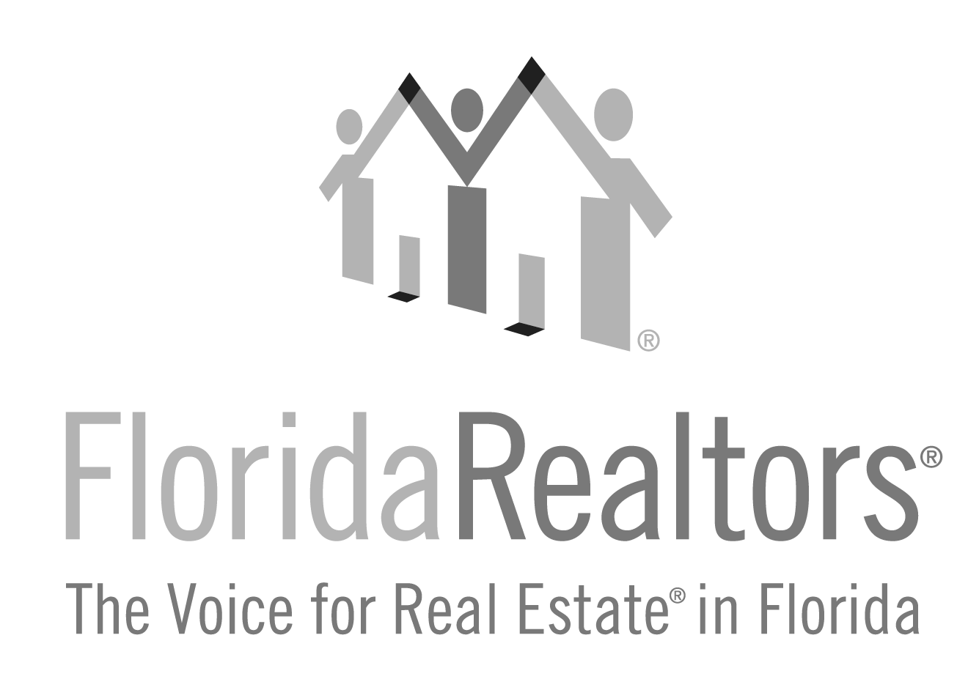

**Newcomer of the Year Award**

*Honoring New Realtor® Members*

**2024 Entry Form**

All applications must be typed with no less than 12-point type size and must be received at Florida Realtors® by **Friday, July 5, 2024.**  One letter of recommendation from the board/association is welcome but not required. If you have any questions, please contact Gina Wittenhagen at (407) 438-1400, ext. 2343 or ginaw@floridarealtors.org

**Full Name of Nominee:**

**When did the nominee become a Realtor® (Month/Day/Year):**

**Nominee’s Board/Association Affiliation:**

**Nominee’s Company & Title:**

**Nominee’s Complete Address:**

**_______________________________________________________________________________________Local Board/Association President or Association Executive’s Signature**

**“**

**Complete and return to:**

*Today’s Newcomers are Tomorrow’s Leaders.*

Florida Realtors®

**”**

Attn: Gina Wittenhagen

7025 Augusta National Drive

Orlando, FL 32822-5017

Application must be received at Florida Realtors by **Friday, July 5, 2024.**

2024 Newcomer Award Entry Form

## Page 2

New (**no more than 3 years as of May 31, 2024**) Realtor® nominees will be judged on (1) Contributions to the state Association including attendance at meetings (2) Ethics and spirit of cooperation as exhibited by faithfulness to the principles of organized real estate Association Bylaws and the Code of Ethics (3) Community service via civic and fraternal organizations including offices or chairmanships held (4) Professional developments as exhibited by attendance at courses, seminars, programs and continuing education that promotes professionalism, self-development and advancement.

Please briefly describe nominee’s accomplishments and involvement.