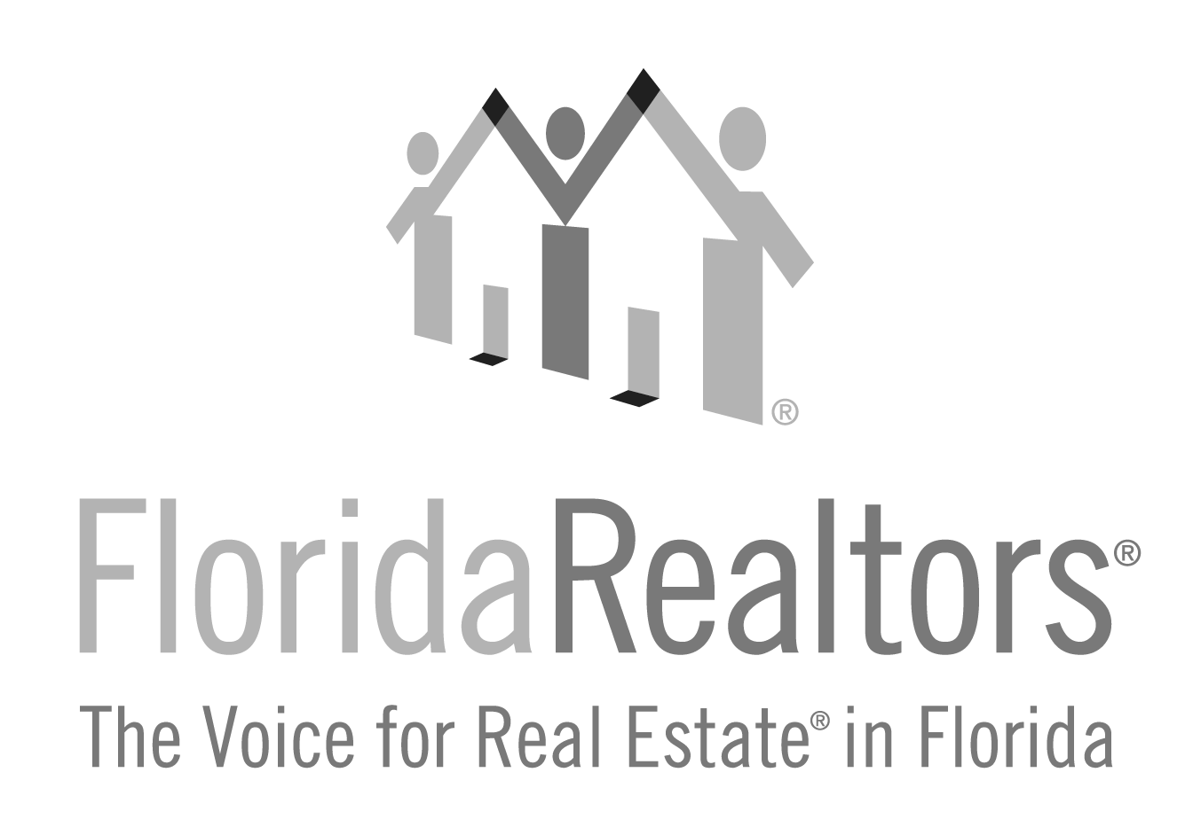

**Spirit of Advocacy**

**2024 Entry Form**

**Honoring a Florida Realtors® member who has exhibited excellence in advocacy at the local board/association, state association, national association and community** **within the governmental/political arena over their *lifetime*. (This is NOT based on monetary donations.)**

All applications must be received at Florida Realtors® by **Friday, July 5, 2024**. If you have any questions, please contact Gina Wittenhagen at (407) 438-1400, ext. 2343 or ginaw@floridarealtors.org

**Full Name of Nominee:**

**Nominee’s Board/Association Affiliation:**

**Nominee’s Company & Title:**

**Nominee’s Complete Address:**

Please check the number of years the applicant has been a Realtor.

1-5 Years

6-10 Years

11-15 Years

16-20 Years

Over 20 Years

Nominee should have a history of investing in the Realtor® Political Action Committee (RPAC). Please check the number of years the applicant has invested.

1-5 Years

6-10 Years

11-15 Years

16-20 Years

Over 20 Years

**_______________________________________________________________________________________Local Board/Association President or Association Executive’s Signature**

**Complete and return to:**

Florida Realtors®

Attn: Gina Wittenhagen

7025 Augusta National Drive

Orlando, FL 32822-5017

Application must be received at Florida Realtors by **Friday, July 5, 2024.**

2024 Spirit of Advocacy Award Entry Form

Page 2

Nominee Considerations

* Attends local, state and national PAC and government affairs meetings
* Knows the elected officials who represent them at all levels of government
* Attends local, state and national candidate events, meet and greets, check presentations, etc.
* Responds to all Florida Realtors, NAR, and Florida Realtors PAC calls for action
* Registered voter
* Attends Great American Realtor® Days in Tallahassee
* Leads by example - has a history of monetarily investing in Florida Realtors® PAC.
* Increases RPAC fundraising efforts through educating the membership on issues and candidates and how they affect your profession, and how and why individual Realtor® contributions of time and dollars make the Realtor® profession significantly stronger.
* Increases Florida Realtors® effectiveness in monitoring and influencing the outcome of local, state and federal issues which impact Realtors®, the real estate industry and the preservation of private property rights.
* Speaks at local and state board meetings and PAC events to educate and promote Florida Realtors® PAC participation
* Educates targeted groups, such as brokers, affiliates, commercial practitioners, top producers, and YPN about PAC initiatives
* Knows the issues and can articulate the Florida Realtors® PAC message
* Increases Florida Realtors® effectiveness through their work within the local, county, district and state political parties.
* Increases Florida Realtors® effectiveness in the recruitment, selection and election of candidates for public office who share a basic philosophy supportive of the Realtor® viewpoint on issues affecting Realtors®, the real estate industry and the rights of all private property owners.
* Shares legislative and political successes with Florida Realtors®

Award Policies

* The Spirit of Advocacy Award will be awarded annually at the Florida Realtors Convention & Trade Show. Winners will also be recognized in Florida Realtors® media.
* Nominations are approved, signed and submitted by local associations.

Suggested Recipients: Those serving their profession and their association through political involvement:

* Members of Florida Realtors® Realtor Advocacy committees.
* Members who serve the community as appointed or elected officials within their local community.
* Members serving the local association by monitoring local governmental units.
* Members serving as Federal Political Coordinators (FPC) to members of Congress.
* Members who have worked closely with their political party of choice, candidate campaigns or local/state ballot issue campaigns.
* ***Current Florida Realtors PAC Trustees, Florida Realtors Officers, GADs, AEs, Affiliate members and staff of Florida Realtors® and affiliated local associations are NOT eligible.***

2024 Spirit of Advocacy Award Entry Form

Page 3

1.What contributions has this Realtor® made to the **local board/association**?

2024 Spirit of Advocacy Award Entry Form

Page 4

2. What contributions has this Realtor® made to the **state association**?

2024 Spirit of Advocacy Award Entry Form

Page 5

3. What contributions has this Realtor® made to the **national association**?

2024 Spirit of Advocacy Award Entry Form

Page 6

4. What contributions has this Realtor® made in their **community**?

Political involvement: (Nominee should have a minimum of five years of political involvement. Please list years and activities in the space provided below. It could be anything from holding political office, working on a campaign, helping to promote or fight a cause (private property rights, rent control, land use, sales tax on services), monitoring city and township activities or sitting on a city or township committee.)